Class 1

* Supervised and unsupervised learning

In *supervised* learning, the goal is to predict the value of an outcome measure based on a number of input measures; in *unsupervised* learning, there is no outcome measure, and the goal is to describe the associations and patterns among a set of input measures.

* Classification vs Regression
  + Variables can be characterized as quantitative/numeric or qualitative/categorical
  + Classification = prediction of a qualitative response
  + Regression = prediction of a quantitative response
* Distinguish machine learning (**ML**) terminology such as features, targets, training, error, etc.
  + **examples** = rows = samples = records = instances (usually denoted by *n*)
  + **features** = inputs = predictors = explanatory variables = regressors = independent variables = covariates (usually denoted by *d*)
  + **targets** = outputs = outcomes = response variable = dependent variable = labels (if categorical).
  + **training** = learning = fitting
* Broadly describe how the **decision tree** algorithm works

What it is?

It is a machine learning model that start from a root and takes a decision that split the data in a left and right branch accordingly with a threshold, using a selected criterion as Gini impurity. You keep doing this split in each branch until you reach the selected maximum deep of the tree.

How?

There are ***NNN*** splits in this decision tree: the firs one is on the variable XXXX…

the first one is on the is_sweet feature with threshold 0.5 (is_sweet $\leq 0.5$) and the second one is on the diameter feature with 3.5 as the threshold (diameter $\leq 3.5$). After the first split on (is_sweet $\leq 0.5$), the data is partitioned in such a way that there is no ambiguity in the target value for one of the partitions. In other words, when is_sweet $&gt; 0.5$ we know right away that the class is Grape. Moreover, the partition is more or less balanced (4 samples on the left and 3 samples on the right). If (diameter $\leq 3.5$) would have been chosen as the first split, the partition would have been unblanced with 6 ambiguous samples (3 grapes, 2 apples, and 1 lemon) on one side and only one sample on the other.

The tree is a Greedy algorithms, doesn’t go back.

Gini:

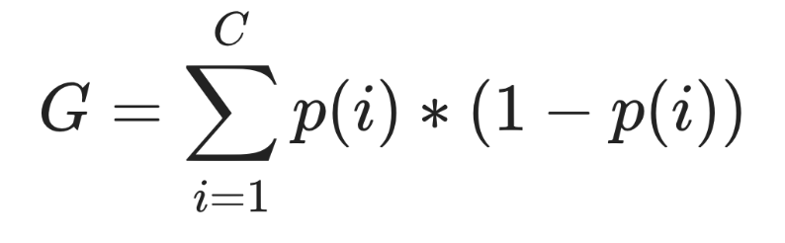

*C* is number of classes in target variable

*p* is proportion of class *i* in a group

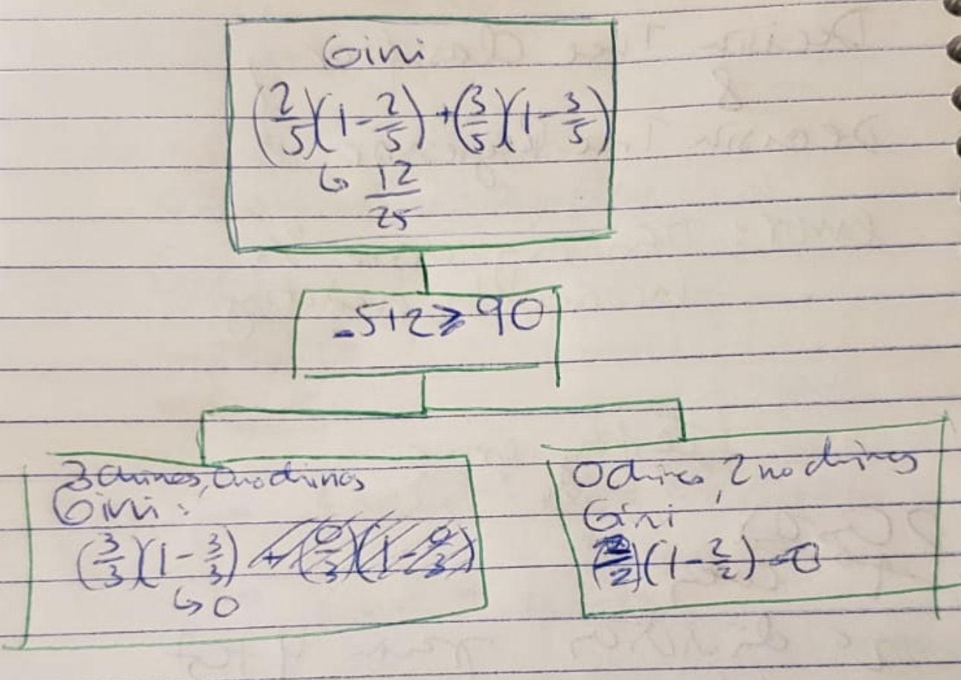

A program with a bunch of if-else statements

Disadvantage: only use some of the features.

|  |  |
| --- | --- |
| Decision **Stump** | Decision tree |
| Image result for decision stump | Image result for decision tree |
| High Training error  High Test error | Low Training error  Higher Test error |
| Low variance  High bias | High variance  Low bias |

* Develop a decision tree model using scikit-learn and the fit/predict paradigm

|  |
| --- |
| from sklearn.tree import DecisionTreeClassifier  # Make an object of Tree Classifier type  model = DecisionTreeClassifier(max_depth=1). 🡨 decision **stump** when max_depth is 1  # separate our data set in features (X) and target(y)  X = data frame with our data  y = ‘target’ which is y vector  # Shuffles and split the data  X_train, X_test, y_train, y_test = train_test_split(X,  y,  test_size=0.2, *🡨 this is the proportion, also can be train_size=0.8, or other proportion*  random_state=123) *🡨 seed*  # Fit the model in train data  model.fit(X_train, y_train);  # Use the model to see predict in test set (also we can do it in train)  model.predict(X_test);  # find the accurancy/error of the model  train_acc = model.score(X_train, y_train)  test_acc = model.score(X_test, y_test)  train_err = model.score(X_train, y_train)  test_err = model.score(X_test, y_test) |

* Describe the difference between parameters and hyperparameters in machine learning models

**Parameters**: When you call fit, a bunch of values get set, like the split variables and split thresholds. Are automatically learned by the algorithm during training

**Hyperparameters**: But even before calling fit on a specific data set, we can set some "knobs" that control the learning. Are specified based on:

* + expert knowledge
  + heuristics, or
  + systematic/automated optimization (more on that in the coming lectures)

**Regression tree** is exactly the same concept as classification tree. But instead of gini, we use some other criteria to base our splits on that can handle continuous values, often we use mean squared error (**MSE**) (see here for other methods)



Class 2

* Identify the difference between training error and testing error

Training error is how well the model fits the data you are using to calculate the model, while testing error is how well the model fits a data set saved to see the performance on other data different from training.

* Describe the concept of overfitting and the fundamental tradeoff

**Overfitting**

This happens when we train our model so well over the training data that it fits the ‘peculiarities’ of our training data and do not generalise well the new data set. The effect is that the training error is very very low (sometimes zero), and the testing error is high. We get high variance and low bias of the model.

Wikipedia: is "the production of an analysis that corresponds too closely or exactly to a particular set of data, and may therefore fail to fit additional data or predict future observations reliably

<https://en.wikipedia.org/wiki/Overfitting>

Report scoring:

* The training accuracy is much higher than the test accuracy suggesting that the model is overfit on the training data.

**Fundamental trade-off**

There is a trade-off between complexity and test error: as the complexity of the model increases, it fit closer to the peculiarities of the training data, so the bias decreases but the variance increases.

When complexity of the model increase, the bias decrease but the variance increase.

|  |  |  |
| --- | --- | --- |
|  | **Overfitting**  *(highly sensitive to training set)*  *High variance*  *Low Bias* | **Underfitting**  *(not sensitive to training set)*  *Low variance*  *High Bias* |
| Decision Tree | higher depth | Decision stump (depth=1) |
| kNN | k=1 neighbours | k very high |
| Naïve Bayes |  |  |

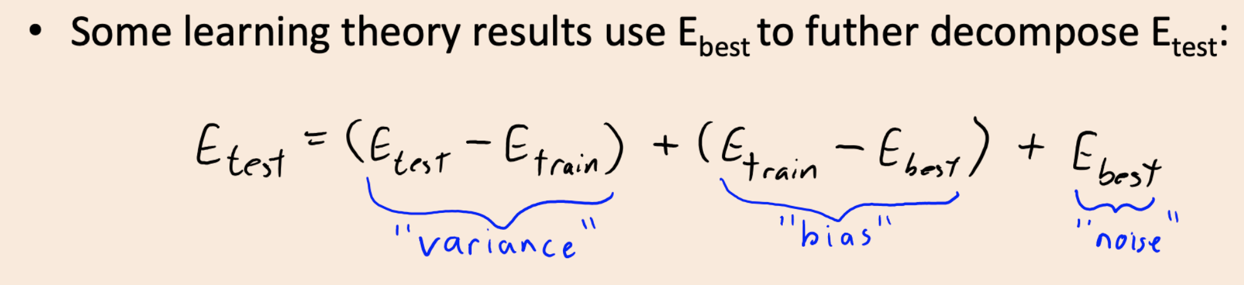

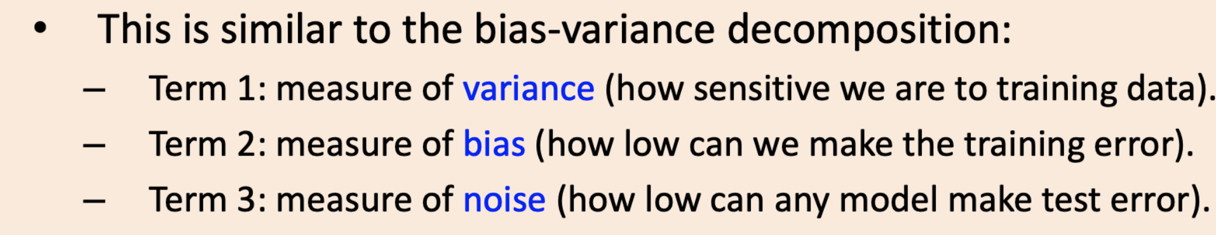

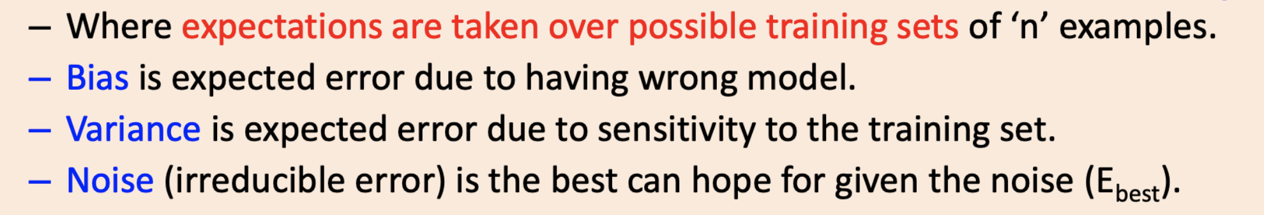

* Describe cross-validation and use .cvscore() to calculate cross-validation error

**Cross-validation** split your data 1 time in two groups: train data and test data.

(A: is just fitting and predicting one data)

Problems:

1. Only use a portion of your data for training/testing,
2. If dataset is small, tiny training/testing set,
3. Might be unlucky with your splits such that they don't well represent your data.

**K-fold** **Cross-validation**

Type of Cross validation when you split your data k groups and, fit and predicts k times using each of the k-folds as a test group vs the other data.

data dividing the data k times. Each "fold" gets a turn at being the validation set

We then average our k results

1. use all of our data for training/testing!
2. "robust" measure of error on unseen data
3. Split the data into k-folds (k>2, often k=10)
4. Each "fold" gets a turn at being the validation set. We then average our k results

(A: fits and predicts k splits of the data)

|  |  |  |
| --- | --- | --- |
| from sklearn.model_selection import cross_val_score  df = pd.read_csv('data/cities_USA.csv', index_col=0)  X = df.drop(columns=['vote'])  y = df[['vote']]  model = DecisionTreeClassifier(max_depth=1)  cv_score = cross_val_score(model, X, y, cv=10)  cv_score   |  | | --- | | array([0.41463415, 0.41463415, 0.41463415, 0.68292683, 0.825 ,  0.6 , 0.58974359, 0.58974359, 0.58974359, 0.58974359]) |   print(f"Average cross-validation score = {np.mean(cv_score):.2f}") #We use obtain the average of the score or error   |  | | --- | | Average cross-validation score = 0.57 | |

* Describe the golden rule and why it's important

The Golden Rule: standardizing/normalizing the test set separately

Given the iid assumption, you need to apply the SAME preprocessing steps to train/test.

Otherwise you're making the test data different from the training data.

And/or you might be allowing information from the test set to leak into the training step.

The below code looks very worrying (and I often see it in practice!)



Class 3

* Broadly describe how the kNN algorithm works.

**Classification**: it looks for the k-nearest neighbors group’s and predict that the new observation would belong to the group with the higher proportion of these neighbors.

**Regressor**: Very similar, but returns the proportion.

k is a hyperparameter. Recall that we typically choose hyperparameters by:

* + expert knowledge
  + heuristics, or
  + systematic/automated optimization (more on that in 573)

|  |
| --- |
| from sklearn.model_selection import train_test_split, cross_val_score  # split into training/validation and testing set  X_train, X_test, y_train, y_test = train_test_split(X,  y,  test_size=0.2,  random_state=123)  model = KNeighborsClassifier(n_neighbors=**k**).fit(X_train, # here could have k = 1, 2, 3, …  y_train.to_numpy().ravel())  # score for the train  train_error = 1 - model.score(X_train,  y_train)  # here we are making k-folds cross-validation  cv_error = 1 - cross_val_score(model,  X_train,  y_train,  cv=5).mean()  # score for the test  test_error = 1 - model.score(X_test,  y_test) |

* Discuss the effect of using a small/large value of the hyperparameter k when using the kNN algorithm.

Small **k** overfit, large k underfit.

* Describe the difference between normalising and standardising and be able to use scikit-learn's MinMaxScaler() and StandardScaler() to pre-process numeric features.

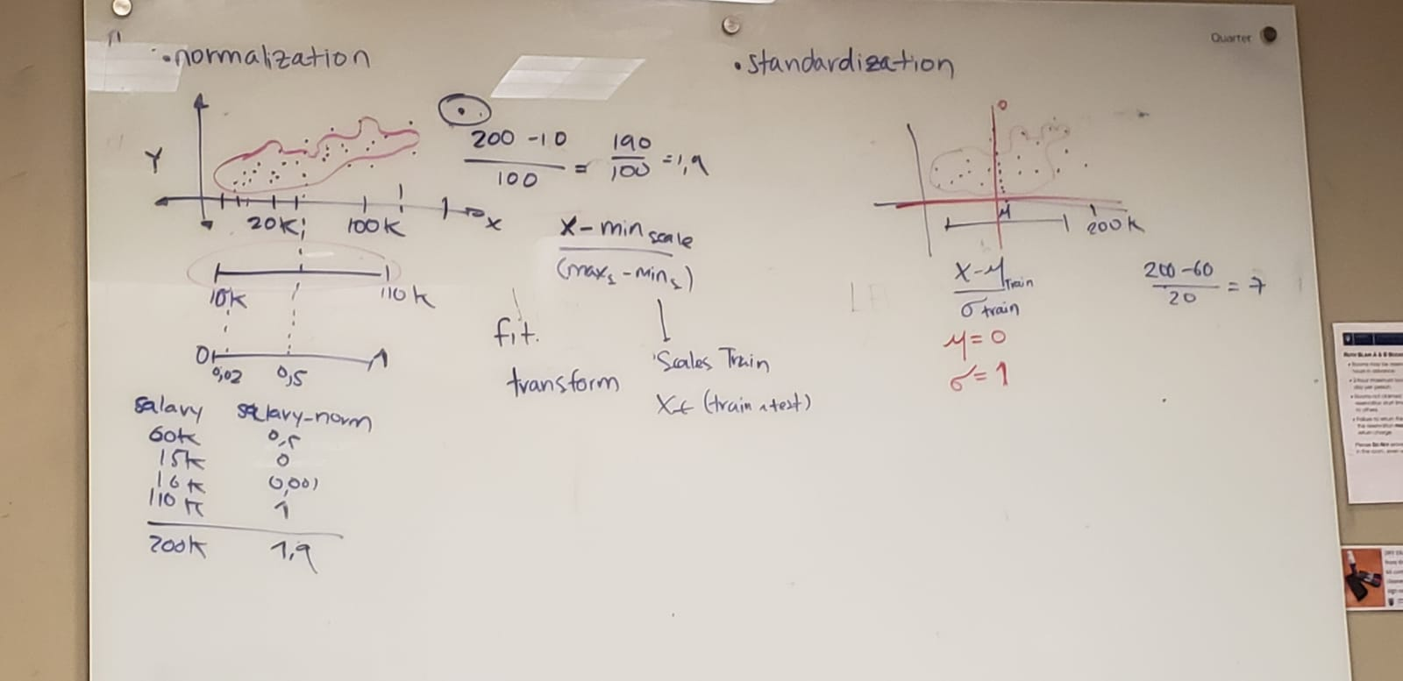

|  |  |
| --- | --- |
| from sklearn.preprocessing import StandardScaler, MinMaxScaler  scaler = StandardScaler()  scaler.fit(X_train2)  X_train2_scaled = scaler.transform(X_train2)  X_test2_scaled = scaler.transform(X_test2)  knn = KNeighborsClassifier(n_neighbors=1)  knn.fit(X_train2_scaled, y_train)  print(f"Training error: {1 - knn.score(X_train2_scaled, y_train):.2f}")  print(f"Test error: {1- knn.score(X_test2_scaled, y_test):.2f}")   |  | | --- | | Training error: 0.00  Test error: 0.06 | |

|  |  |
| --- | --- |
| minmax = MinMaxScaler()  minmax.fit(X_train2)  X_train2_minmax = minmax.transform(X_train2)  X_test2_minmax = minmax.transform(X_test2)  knn = KNeighborsClassifier(n_neighbors=1)  knn.fit(X_train2_minmax, y_train)  print(f"Training score: {1 - knn.score(X_train2_minmax, y_train):.2f}")  print(f"Test score: {1 - knn.score(X_test2_minmax, y_test):.2f}")   |  | | --- | | Training score: 0.00  Test score: 0.06 | |

The Golden Rule: standardizing/normalizing the test set separately

Given the iid assumption, you need to **apply the SAME preprocessing steps to train/test**.

Otherwise you're making the test data different from the training data.

And/or you might be allowing information from the test set to leak into the training step.

The below code looks very worrying (and I often see it in practice!)

* Idenitfy when to implement pre-processing techniques like standardization in a machine learning model development pipeline.
* Parametric and not parametric
  + Parametric model Y=a+bX (regression) > Doesn’t grow when you aggregate one more data. NUMBER OF PARAMETERS DOESN’T CHANGE – IT IS FINITE – Si tienes una regression con dos betas, y agregas 1 dato enonces calculas solo las 2 betas siempre que agregues datos
  + Not parametric like KNN > it grows and you need to calculate again when you aggregate data. NUMBER OF PARAMETER ASSUMES THAT HE MODEL CAN’T BE DEFFINE IN THE NUMBER FINITE PARAMETERS – cambia el numero de parametros, es decir se incrementan los parametros cada vez que se agregue data.

Tree ambiguous, number of threshols

KNN – (no parametric, all the distances for the new data point need to be calculated)

- *k* is a hyperparameter

- Recall that we typically choose hyperparameters by:

- expert knowledge

- heuristics, or

- systematic/automated optimization (more on that in 573)

Naïve Bayes – Parametric.

Normalization vs . Standarization



Laplace smoothing

$$\frac{ factor+ alpha}{resp+2×alpha}$$

$$\begin{matrix}1 & 1 \\ 0 & 1 \\ 1 & 0\end{matrix}$$

Naïve Bayes

Consensus are parametric –

But

1. Why do we include (alpha x d) in the denominator when applying Laplace smoothing and why do we multiply it by d? Why not just apply the smoothing in the numerator?

:The alpha * d term is there to normalize the smoothing. Maybe you can think of it like this: if we only added alpha in the numerator we would be unfairly modifying our results. If I had a word count of 1 initial and then added alpha = 1 I just double the numerator for that specific word (i.e., a relative increase of 100%). However, if I have a different word with a count of 10 initially, adding alpha = 1 is only a relative increase of 10%. The alpha in the numerator helps to normalize this unfairness. I wonder if Q2 in the lab might help understand this more?

1. When using one-hot encoding if we have n unique categories, then why do we care about reducing to n-1 categories? For example, if we have n = 100, what is the point of reducing down to n = 99? It is not clear to me how reducing one category will improve our model performance.

:You are talking about a more extreme case where OHE adds 100 columns. In this case, dropping the first column such that we have only 99 won't make a huge difference to our model performance. What we typically do in practice after OHE is something called feature reduction (e.g., principal components analysis) to reduce the number of columns (more on this in 573). However, in more simple cases, the difference between 3 columns and 4 columns for example, can make a big difference in your model. The other reason for dropping the first column has to do with the multicollinearity introduced into the dataset (Gaby will talk about OHE/dummy encoding and this "multicollinearity" issue more next week).

1. In the context of dealing with both categorical and numerical variables, what does ColumnTransformer do in the background? Are we required to always use ColumnTransformer whenever we have any categorical variables?
2. Bonus! - Why is Naive Bayes often considered a parametric model?

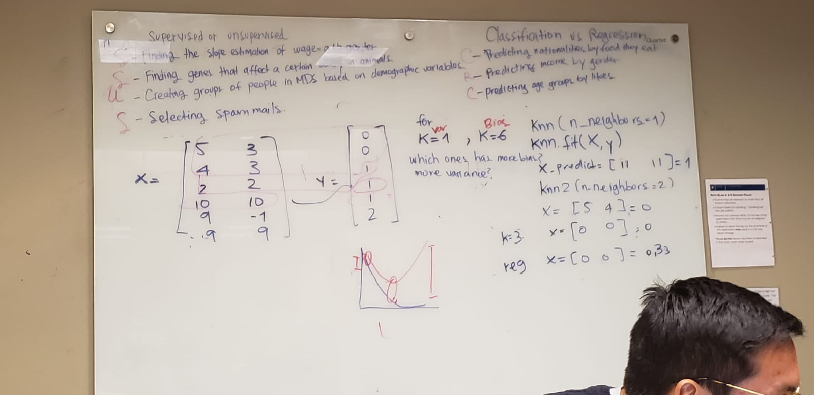

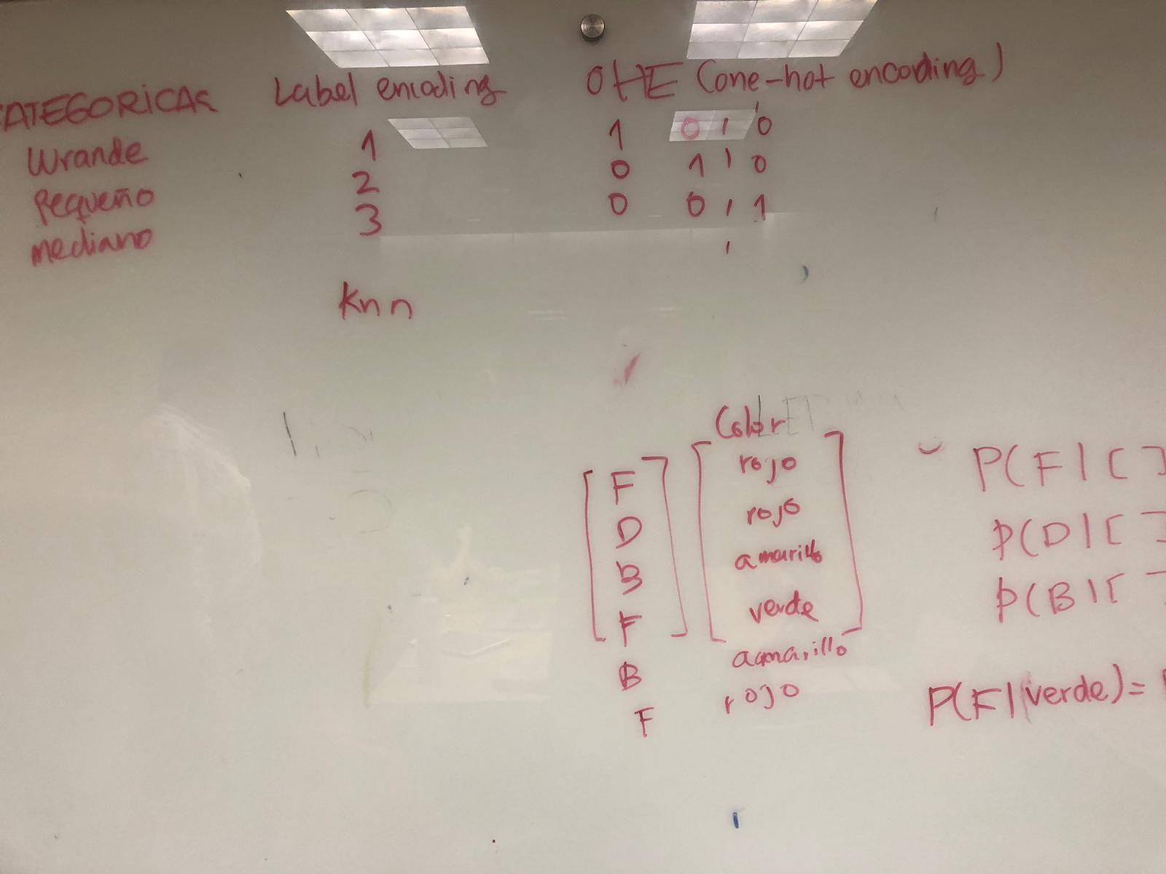

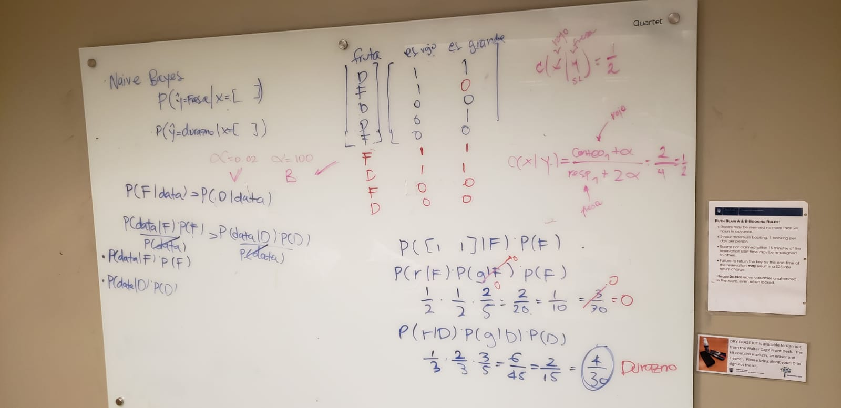

Class 6

### SVM motivation: Which decision boundary is better?[¶](http://localhost:8888/notebooks/Documents/UBC/B3_2019/lectures/DSCI_571_sup-learn-1_students/lectures/lecture6_svms_random_forests.ipynb#SVM-motivation:-Which-decision-boundary-is-better?)

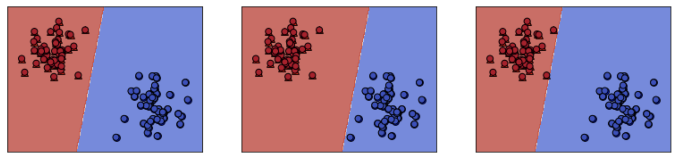

Choose a hyperplane that maximize the distance

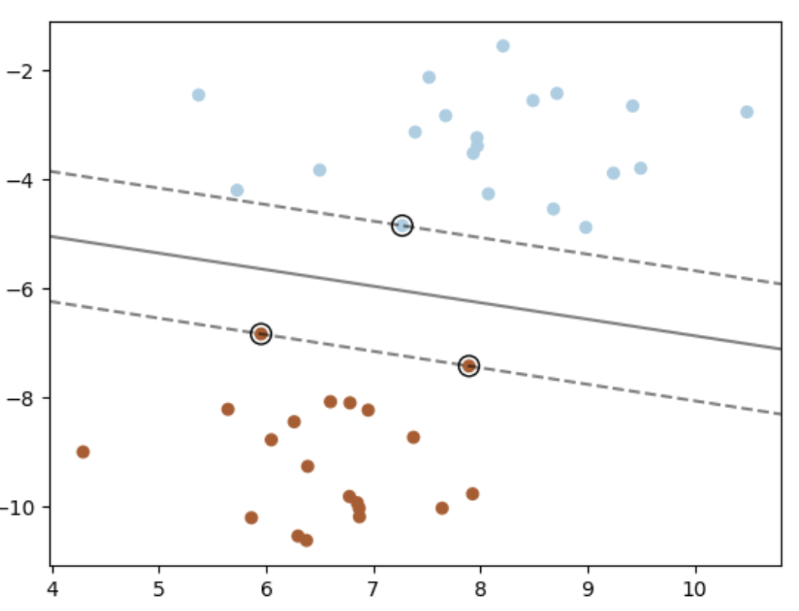

The idea: decision boundary only based in support vectors

|  |  |  |
| --- | --- | --- |
|  | 🡪 |  |

**Main idea: the decision boundary only depends on the support vectors.**

***Support vectors are data points.

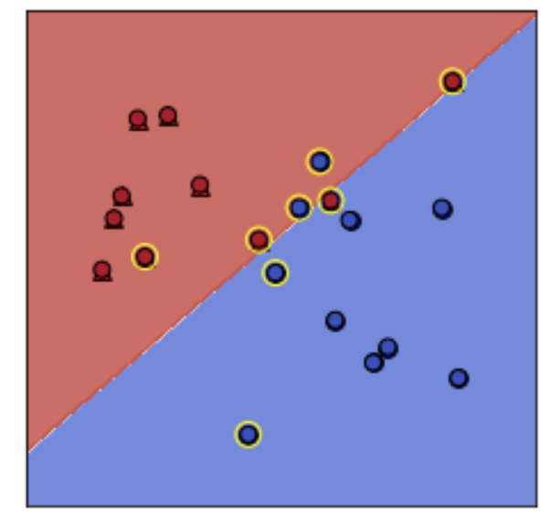

HOW DO I OBTAIN SUPPORT VECTORS? ARE POINTS PART OF THE TRAINING DATA?

The support vectors (SVs) are shown in yellow. These are the example that "support" the boundary.

### Nonlinear SVM

Do SVMs work only with linearly-separable data?

* No. We can use the "kernel" trick to deal with non linearly separable surfaces

|  |  |  |
| --- | --- | --- |
|  | 🡪 |  |

Hypermatarameters

Gamma:

Larger gamma large fluctuation: overfitting, complex model

Small gamma, undefiting???

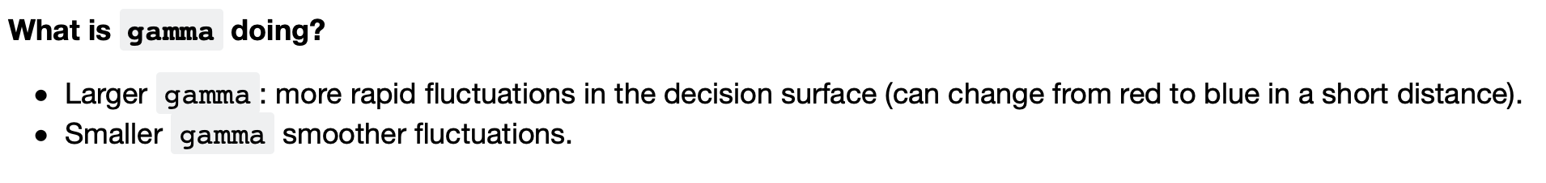

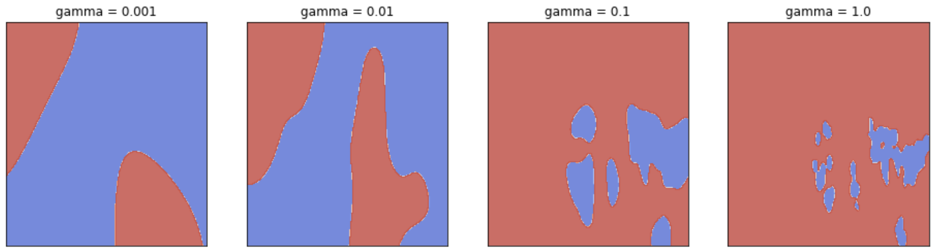

C:

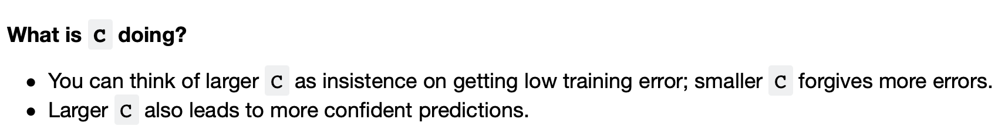

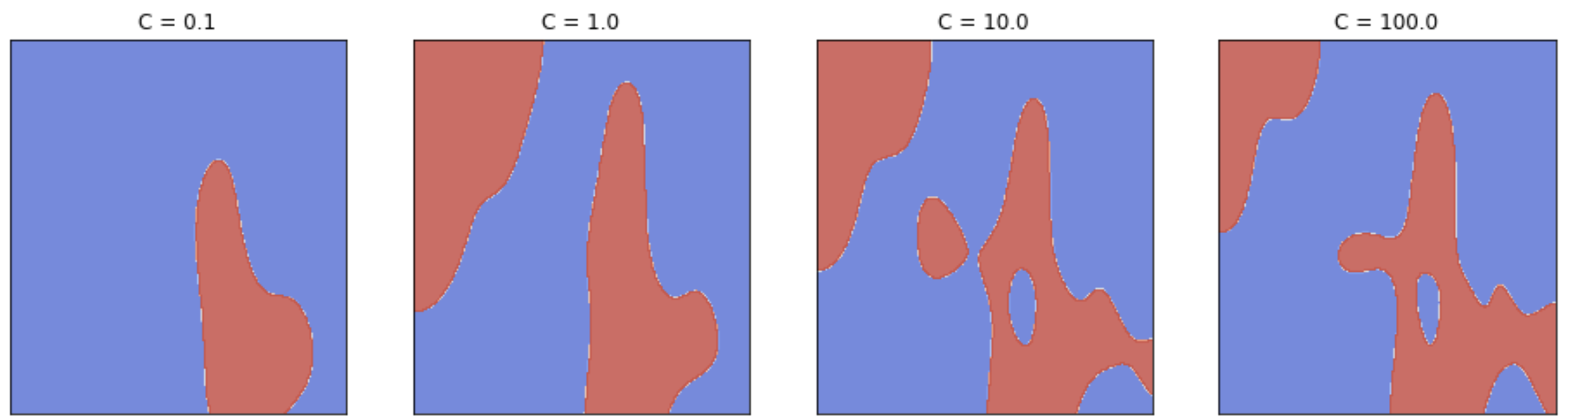

### Relation of gamma and the fundamental trade-off

* gamma controls the complexity (fundamental trade-off), just like other hyperparameters we've seen.
  + larger gamma →→ more complex
* C also affects the fundamental tradeoff, although in a less intuitive way.
  + larger C →→ more complex

### Multi-class, meta-strategies

|  |  |  |
| --- | --- | --- |
|  | 🡪 |  |

MULTI VS ONE-TO-ONE

SEE THIS WELL

MACHINE LEARNING 🡪 SEARCH!!!

**Random Forest**

Collection of trees, grow the tree on independent bootstrap sample from the data.

1st randomness: bootstrap

2nd randomness: at each spilt